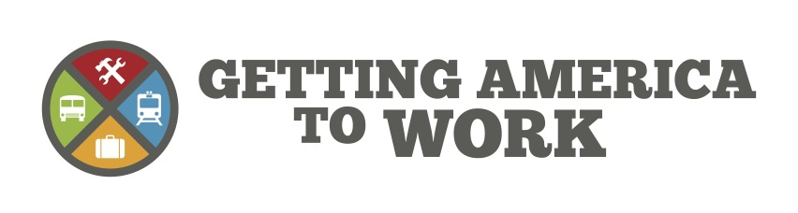

DATE:
September 23, 2013

CONTACT:
Bryan DeAngelis
202-331-1002

[Transit Agency] Applauds U.S. Representative [Name]’s Decision to Join Congressional Public Transportation Caucus

Washington D.C. – Getting America to Work welcomes [First/Last Name]’s (Party-State, i.e. D-NY) decision to become a member of the newly formed Congressional Public Transportation Caucus.

“Representative [Last Name] understands the importance of public transit to the economy and communities in their district and across the nation,” said Joe Costello, Executive Director of the Northeastern Illinois Regional Transportation Authority and founding member of the transit advocacy group Getting America to Work. “Keeping our country’s transit systems operating in a state of good repair has myriad benefits, from creating jobs to reducing travel times and improving quality of life.”

Research shows that every dollar spent on transit generates an economic return of at least 4 to 1 and every $1 billion of capital spending on transit creates 24,000 jobs, according to a report by the Economic Development Research Group. Additionally, transit has been shown to increase nearby property values and relieve the economic costs and pollution caused by traffic congestion.

With many systems across the nation facing increasing ridership and diminishing federal funds, leadership in Congress is needed now more than ever before. Transit is a key component of America’s transportation system, which is the backbone for the country’s economy. GATW applauds Rep. [Last Name] leadership on this issue, and hopes the Caucus will focus more national attention on this critical need.

The bipartisan Public Transportation Caucus was launched by Rep. Dan Lipinski (D-IL) and Rep. Michael Grimm (R-NY) earlier this year. It will provide a forum for members of Congress to engage in constructive dialogue about the challenges and needs of mass transit agencies across the country. The first meeting of The Congressional Public Transportation Caucus was held last week and featured a robust discussion on a variety of transit related issues led by Representatives Grimm and Lipinski.

Getting America to Work (GATW) is a broad coalition of commuters, businesses, officials and transportation agencies that support vital investments in public transit. GATW focuses on advocating for the capital funding necessary to bring all of America’s public transportation systems into a state of good repair. This investment will preserve and create the jobs and economic development transit supports. For more information, visit www.GettingAmericaToWork.org.

###

