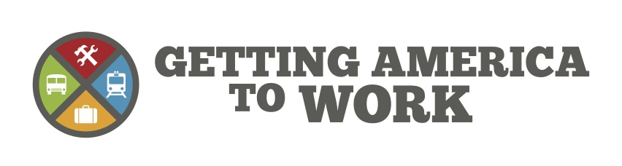
[Insert Your Logo]

DATE: [Date]

CONTACT: [Name, Phone, Email]

[Your Region] Business Leaders Call for Increased Transit Investment

[Insert Group] Joins Getting America to Work Coalition to Support Federal Funding Needed to Repair and Replace Aging Transit Assets

[City, State] – Members of the [Insert Group] met with [Transit Agency] to discuss the crucial need for increased capital investment in the region’s bus and rail systems. Existing federal funding is not sufficient to maintain and replace [Your Region’s] aging trains, buses, bridges and stations, which will lead to more delays and congestion and result in less productivity for [Your Region’s] businesses.

“As vehicles get older, transit becomes less reliable,” said [Transit Agency Representative]. “We need more capital funding from Congress to bring transit in [Your Region] and nationwide into a state of good repair.”

“If we do not continue to invest in our bus and rail systems, it will put more cars back on the roads, which means more gridlock and longer travel times,” said [Group Representative]. “It is vital that our employees and customers can reach our businesses reliably and safely.”

[Transit Agency Representative] also touched on the economic benefits of a capital investment in transit. “Every dollar spent on transit generates an economic return of four to one, providing jobs and improving transit performance,” he said. “Keeping our vehicles up-to-date would not only improve commutes but provide significant economic benefits.”

[Insert Transit Agency Boilerplate]

Getting America to Work (GATW) is a broad coalition of commuters, businesses, officials and transportation agencies that support vital investments in public transit. GATW focuses on advocating for the capital funding necessary to bring all of America’s public transportation systems into a state of good repair. This investment will preserve and create the jobs and economic development transit supports. For more information, visit www.GettingAmericaToWork.org

- 30 -

